Infosys Springboard Virtual Internship 7.0 Completion Report
Team Details : FarmVerse – Precision Agriculture Management Platform | Group 1 | Batch 1 – Team C
Team Members: Madhumitha G, Mohit Rathod, Mungara Naga Venkata Rama Chandram, P Koushal, Partheepan Sree Kavya, Yamuna.
Batch Number : 1
Start date : 29/06/2026
Names: P Koushal
Internship Duration: 8 Weeks

1. Project Title
FarmVerse – Precision Agriculture Management Platform | Group 1

2. Project Objective
The main objective of FarmVerse is to develop a web-based Precision Agriculture Management Platform that helps farmers digitally manage their farms and agricultural activities in one place.
The platform aims to reduce manual record keeping, organize farm information, support day-to-day farm management, provide weather information, send useful notifications, and assist farmers with data-driven agricultural decisions.
The system also provides role-based access for Farmers and Administrators and uses secure authentication so that farm-related information can be associated with the correct logged-in user.

3. Project description in detail
FarmVerse is a full-stack web application developed to provide a centralized digital platform for agricultural and farm management.
The frontend was developed using React.js with responsive UI components and navigation for the major application modules. The backend was developed using Java and Spring Boot, with REST APIs connecting the frontend to the server. MySQL was used for persistent data storage.
The application includes public pages such as the Landing Page, About, Contact, Login, and Registration, followed by farmer-facing modules including Dashboard, My Farms, Crop Management, Irrigation, Fertilizer, Reports, and Profile.
Farm management supports adding and viewing farm information and the application is structured to support CRUD operations for farm-related data. Crop Management similarly provides interfaces for adding and managing crop information.
The Irrigation and Fertilizer modules provide dedicated interfaces for recording and managing agricultural activities. The Reports module supports generation of farm-related reports, while the Profile module provides user information management.
Weather functionality is integrated using the Open-Meteo Geocoding API and Open-Meteo Forecast API. The application retrieves location coordinates from a city name and uses current and seven-day forecast data such as temperature, humidity, precipitation, wind speed, and weather condition codes to display farming-oriented weather information.
Email/OTP functionality was integrated for user verification and notification workflows. An SMTP server is configured to send OTPs and email notifications.
An AI crop recommendation feature was integrated using a trained Random Forest Classifier. The model uses Nitrogen (N), Phosphorus (P), Potassium (K), temperature, humidity, pH, and rainfall as input features and predicts a recommended crop from the trained dataset.
The project also includes a profit-estimation feature to provide an additional decision-support workflow for agricultural planning.
Technology Stack
- Frontend: React.js, HTML, CSS, Tailwind CSS and React-based UI components.
- Backend: Java, Spring Boot, Spring MVC and REST APIs.
- Database: MySQL with JPA-based persistence.
- Security: Spring Security and JWT-based authentication.
- AI: Python, pandas, scikit-learn, Random Forest Classifier and joblib.
- Weather: Open-Meteo Geocoding API and Open-Meteo Forecast API.
- Email: SMTP-based email service for OTPs and notifications.
- Testing and development: Postman, Git, GitHub, Maven and IntelliJ IDEA.
Real-world relevance
FarmVerse brings farm records, crop activities, irrigation, fertilizer information, weather data, notifications, reports, and decision-support features into a single digital platform. This helps reduce fragmented record keeping and makes agricultural information easier to access and use.

4. Timeline Overview
Week | Activities Planned | Activities Completed
Week 1 | Project introduction, requirement analysis, technology selection and project planning. | Studied the FarmVerse requirements, modules, user roles and overall application workflow.
Week 2 | Develop the basic backend structure and database foundation. | Set up the Spring Boot backend, MySQL database and basic project structure.
Week 3 | Develop the landing page, navigation and initial UI components. | Completed the landing page, navigation, sidebar, top bar and major basic UI components.
Week 4 | Implement authentication and secure user access. | Implemented user registration/login, JWT authentication and role-based access.
Week 5 | Develop Farm and Crop CRUD operations and connect them with the backend. | Implemented Add, View, Update and Delete operations for farms and crops and connected them with the backend.
Week 6 | Develop Irrigation and Fertilizer CRUD operations. | Implemented CRUD operations for irrigation and fertilizer management.
Week 7 | Integrate APIs, testing, report generation and application improvements. | Integrated frontend and backend APIs, tested APIs using Postman, implemented report generation and integrated weather/AI-related workflows.
Week 8 | Complete email/OTP notifications, final testing, debugging, responsive UI and documentation. | Integrated SMTP-based email/OTP notifications, completed final testing, fixed errors, improved responsive UI, verified major modules and prepared documentation.

5a. Key Milestones
Milestone | Description | Date Achieved
Project Kickoff | Started the FarmVerse project and analyzed the requirements. | Week 1
Prototype/First Draft | Completed the initial frontend and backend structure. | Week 2–3
Mid-Term Review | Completed authentication, dashboard and major management modules. | Week 4
Final Submission | Completed major features, integration, testing and documentation. | Week 8
Presentation | Prepared the application demonstration and project documentation. | Week 8

5b. Project execution details
The project was executed using a full-stack architecture in which the React frontend communicates with Spring Boot REST APIs, while MySQL provides persistent storage.
1. Requirement Analysis: The team identified the required user roles, modules, workflows and application requirements for FarmVerse.
2. System and Database Design: The database foundation was designed around user, farm, crop, irrigation and fertilizer information with relationships between the records.
3. Backend Development: Spring Boot was used to create the backend structure and REST APIs. Authentication and protected access were implemented using Spring Security and JWT.
4. Frontend Development: React.js was used to build the Landing Page, authentication pages, Dashboard, farm/crop management, irrigation, fertilizer, reports, profile and additional feature screens.
5. Integration: Frontend requests were connected to backend APIs, with user-specific data retrieved from the authenticated context and persisted in MySQL.
6. External Services: Open-Meteo was integrated for location and weather data, and an SMTP server was configured for OTP and email notifications.
7. AI Integration: A Random Forest model was trained using crop recommendation data. The prediction workflow uses N, P, K, temperature, humidity, pH and rainfall as model inputs.
8. Testing and Debugging: Postman, browser developer tools, backend logs, database records and API responses were used to identify and resolve integration and validation problems.
9. Final Improvements: Responsive UI, error handling, success messages, dynamic dashboard data, weather information, notifications and additional decision-support features were refined before completion.
Implementation Flow
1. Project Requirement Analysis
2. System & Database Design
3. Frontend & Backend Structure
4. Database Implementation
5. User Registration & Login
6. JWT Authentication & Role Management
7. Dashboard Implementation
8. Farm Management
9. Crop Management
10. Irrigation Management
11. Fertilizer Management
12. Profile Management
13. Weather Integration
14. AI Crop Recommendation & Profit Estimation
15. Report Generation
16. Email / OTP Notification
17. Frontend–Backend Integration
18. API Testing using Postman
19. Debugging & Error Handling
20. UI Improvements & Responsive Design
21. Final Testing
22. Project Completion & Documentation

6. Snapshots / Screenshots
The following screenshots are retained from the original project report and show the FarmVerse interface, authentication, farm management, OTP verification and email notification work.
Figure 1. FarmVerse Landing Page
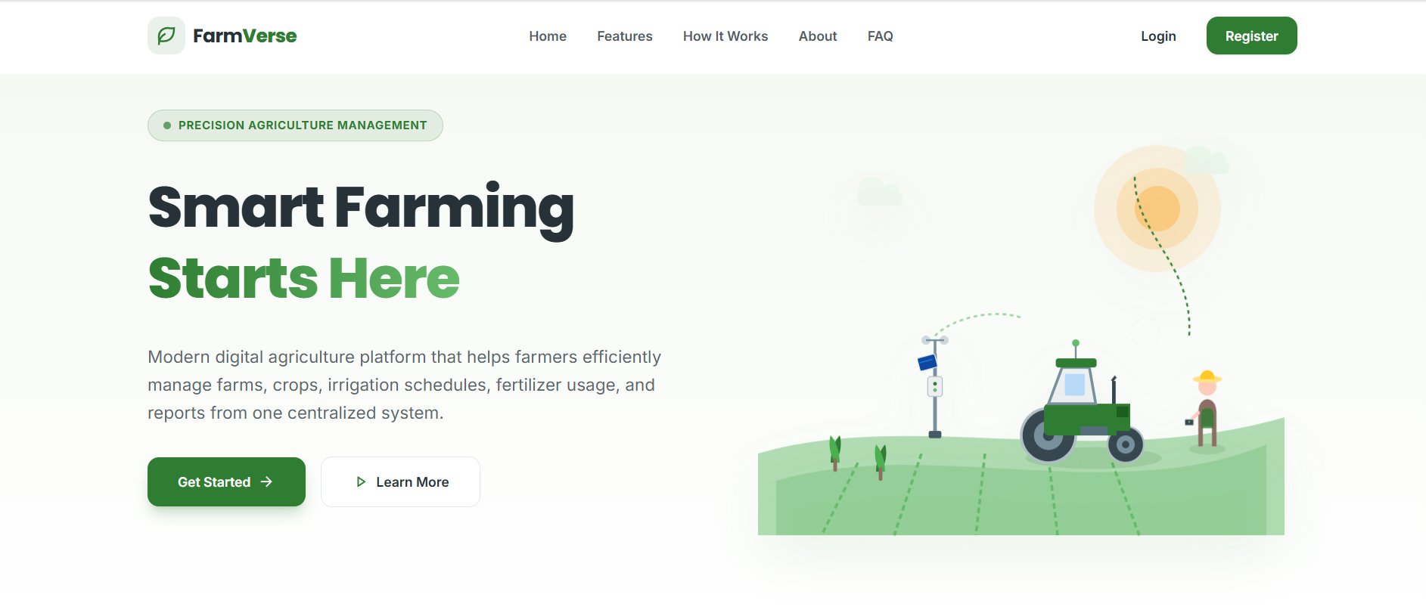
Figure 2. Authentication Flow
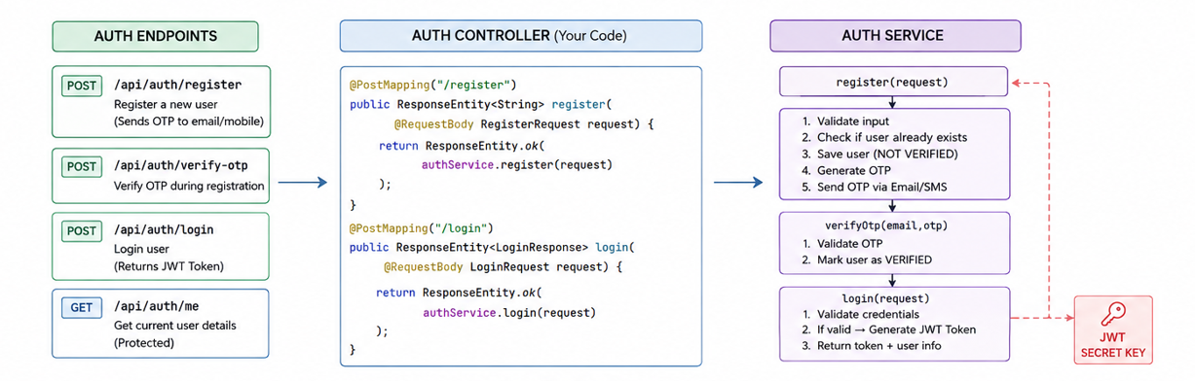
Figure 3. Farm CRUD Flow
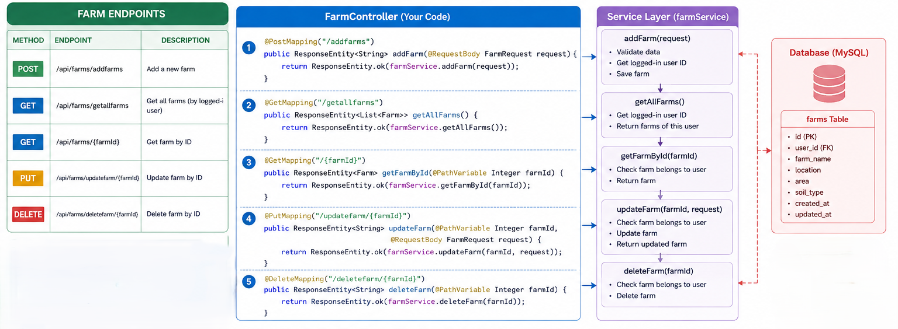
Figure 4. Add Farm Form
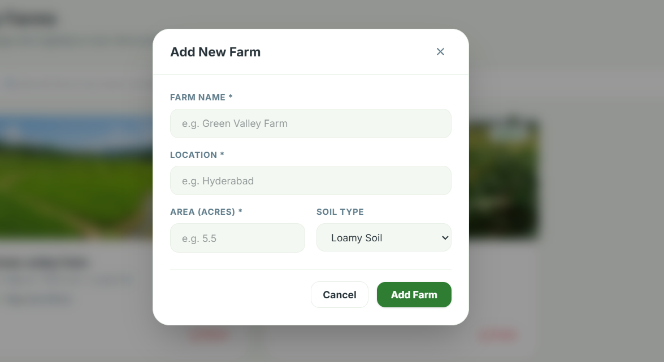
Figure 5. OTP Verification – Code Snippet
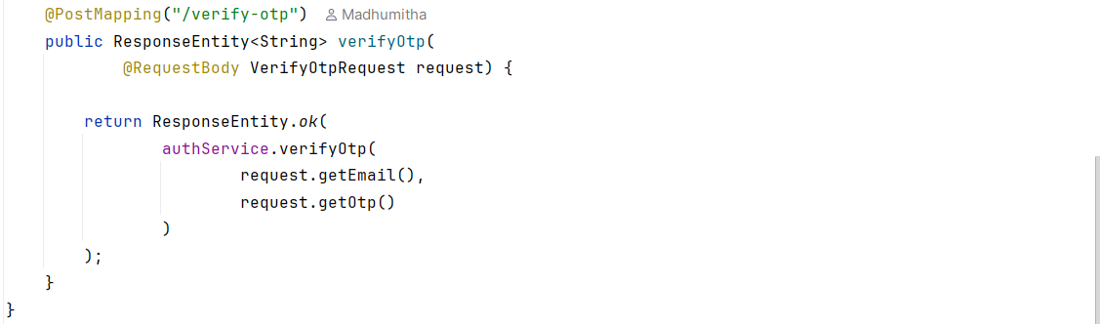
Figure 6. User Verification Status
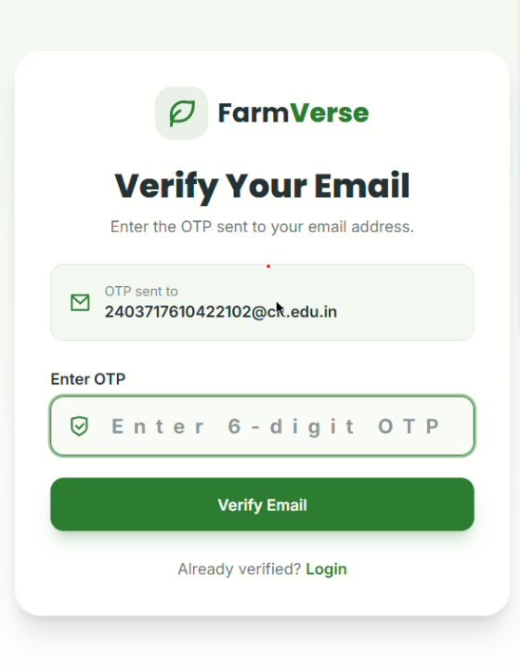
Figure 7. Email Notification – Code Implementation
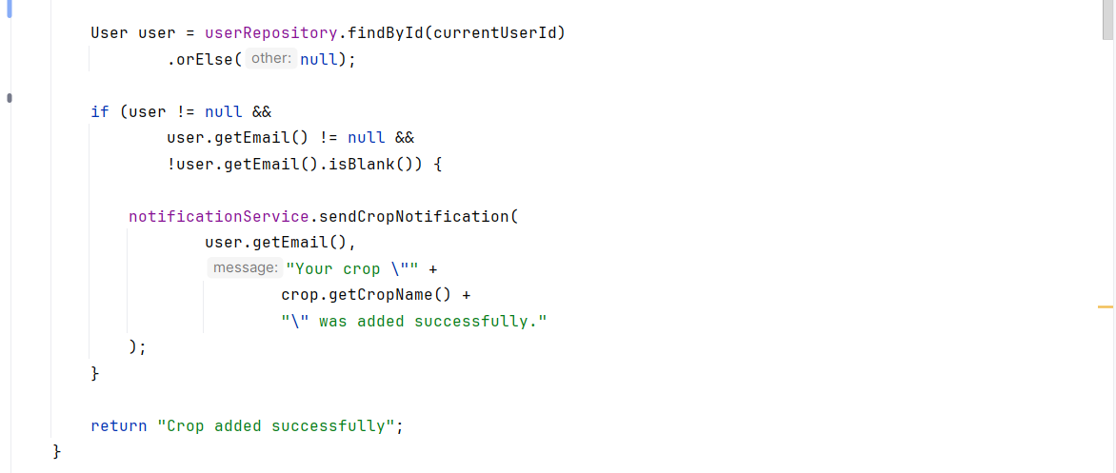
Figure 8. Email Notification
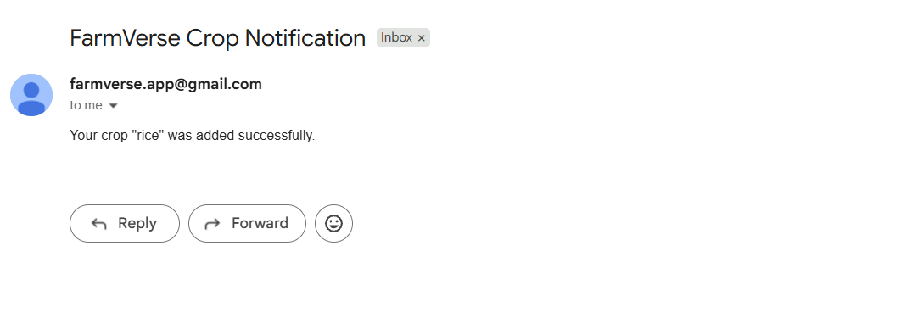

7. Challenges Faced
During development, the team encountered several technical challenges related to authentication, API integration, user-specific data, database relationships, external services and debugging.
Authentication and Authorization
Implementing JWT authentication and ensuring that only authenticated users could access protected pages was challenging. Spring Security and JWT-based authentication were configured to protect backend endpoints.
User-Specific Data
The application needed to ensure that a farmer could access only their own farm and crop records. The authenticated user's ID was used when retrieving or adding farm-related data.
Frontend and Backend Integration
Connecting React components with Spring Boot REST APIs required matching request payloads, endpoints and response formats. APIs were tested with Postman before frontend integration.
API Errors and Validation
Errors such as 400 Bad Request and 403 Forbidden occurred during authentication and API testing. Request payloads, JWT tokens, backend logs, Postman responses and database records were checked to resolve them.
Dynamic Dashboard
The dashboard needed to display information based on the currently logged-in user instead of fixed values. Dashboard data was retrieved dynamically from the backend.
Email / OTP Integration
Configuring an SMTP server and connecting OTP generation, verification and notification flows required careful configuration and testing.
Weather and External API Integration
Weather data required location geocoding and forecast requests with correct parameters. Open-Meteo responses were mapped into user-friendly weather and farming insights.
AI Model Integration
The AI recommendation workflow required consistent feature names and input values between the trained model and prediction service. The trained Random Forest model was saved and loaded for prediction.

8. Learnings & Skills Acquired
The internship provided practical experience in full-stack software development and the complete workflow of building, integrating, testing and documenting a web application.
Technical Skills
- React.js development and component-based UI design
- Spring Boot and REST API development
- Spring Security and JWT authentication
- MySQL database design and management
- CRUD operations and frontend–backend integration
- Postman API testing and debugging
- Git and GitHub version control and collaboration
- Responsive UI development
- PDF report generation
- Open-Meteo API integration
- SMTP email and OTP integration
- Python-based machine learning integration
- Random Forest model training and prediction workflow
Professional Skills
- Problem solving
- Debugging
- Requirement analysis
- Project planning
- Documentation
- Time management
- Testing and validation
- Team collaboration
- Understanding real-world software development workflow

9. Testimonials from team
The internship provided valuable practical experience in developing a full-stack web application. Working on FarmVerse helped in understanding how frontend interfaces, backend APIs, databases, authentication and external services work together in a real project.
The development process improved technical knowledge as well as problem-solving, debugging, testing and team collaboration skills. It also provided practical exposure to Git/GitHub-based development and integration of weather, email and AI-assisted features.

10. Conclusion
The FarmVerse – Precision Agriculture Management Platform was successfully developed as a full-stack web application for managing agricultural activities.
The project includes user registration and authentication, JWT-based security, role-based access, dashboard, farm management, crop management, irrigation management, fertilizer management, profile management and report generation.
The application was further enhanced with Open-Meteo weather integration, SMTP-based email/OTP notifications, AI-based crop recommendation using a trained Random Forest model, and profit-estimation functionality.
The internship provided practical experience in React.js, Spring Boot, MySQL, REST APIs, JWT authentication, external API integration, machine-learning integration, API testing, Git/GitHub and software development practices.
Overall, the project helped bridge the gap between academic knowledge and practical software development and provided experience in developing, integrating, testing, debugging and documenting a real-world full-stack application.

11. Acknowledgements
I would like to express my sincere gratitude to the organization for providing me with the opportunity to complete this internship and work on the FarmVerse – Precision Agriculture Management Platform.
I would like to thank my mentor Vinay Prashant and my team members for their guidance, support, feedback and encouragement throughout the project.
I am also grateful to my institution and faculty members for their continuous support and for providing the academic guidance required to successfully complete this internship.
The knowledge and practical experience gained during this internship will be valuable for my future academic and professional career.

